Final Project Assignment – Java Programming
Phase 4 – Final Report

Project Title: Daily Student Expense Tracker with Spending Score
Team Name: Team Start-Up
Course: COP2800 Java Programming
Team Members: Jose G. Leon Zambrano (Lead Developer), Manuel Salazar (Project Coordinator / Developer), Diego Cabrera (Developer), Julien Morales (Documentation and Presentation)
PROJECT GITHUB: https://github.com/JGLeonZambrano/COP2800-FinalProject

Overview and Purpose
The Daily Student Expense Tracker is a Java Swing desktop application that lets a student record income and expenses, review their history, and see a single score describing how well they are managing their money.
Most budgeting tools only show a balance, which says how much is left but not whether it was spent sensibly. The Spending Score adds that layer: it combines how much income remains (60%), how closely spending follows the 50/30/20 rule (30%), and whether any single purchase was unusually large (10%). When the score is low, or a childcare expense is recorded, the Statistics screen links directly to Miami Dade College support services, so a low score points toward help rather than just delivering bad news. Data is saved to CSV and settings to a separate file, so the program works as an ongoing tool.
Key Features
- Login with a five-attempt limit, three-minute lockout, and a password change that is saved between sessions
- Income and expense entry with type-dependent categories, field validation, and duplicate detection
- History sorted newest first, with All / Last 60 Days / Custom Range filters and expense statistics
- Composite Spending Score with unusual-expense detection and links to MDC Single Stop, TRIO, and Student Parents
- CSV export with a dated filename, and automatic save on exit or window close
The Program Running
A typical session, login through saving. The full set of thirty-four screenshots is in the docs folder, in the testing files from Diego Cabrera and Manuel Salazar.
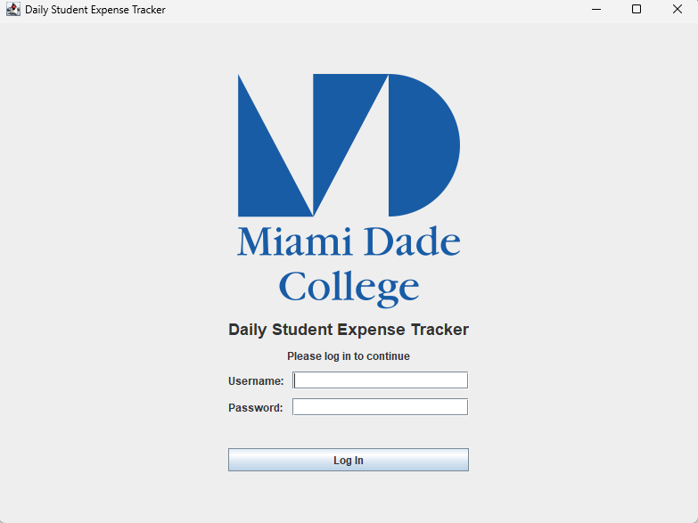  Fig 1. Login screen. | 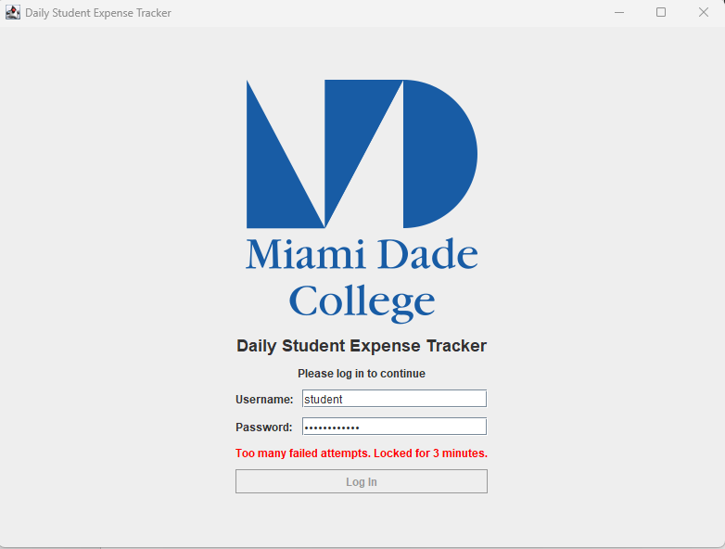  Fig 2. Locked after 5 failed attempts.
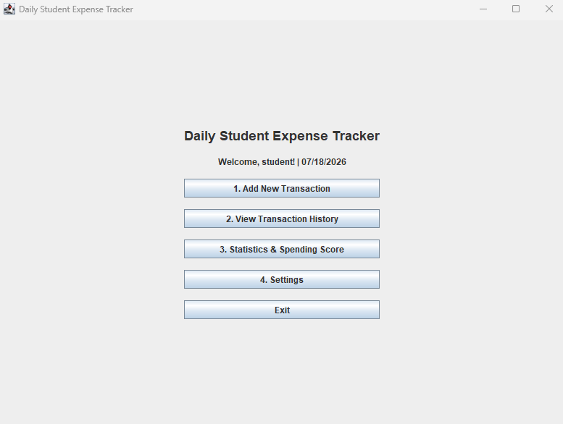  Fig 3. Main menu with current score. | 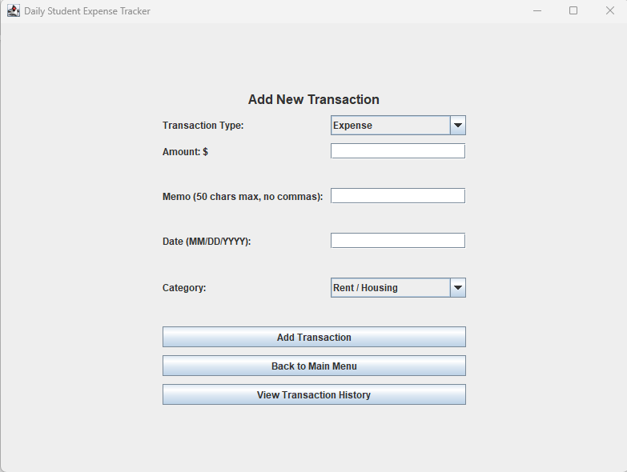  Fig 4. Add Transaction screen.
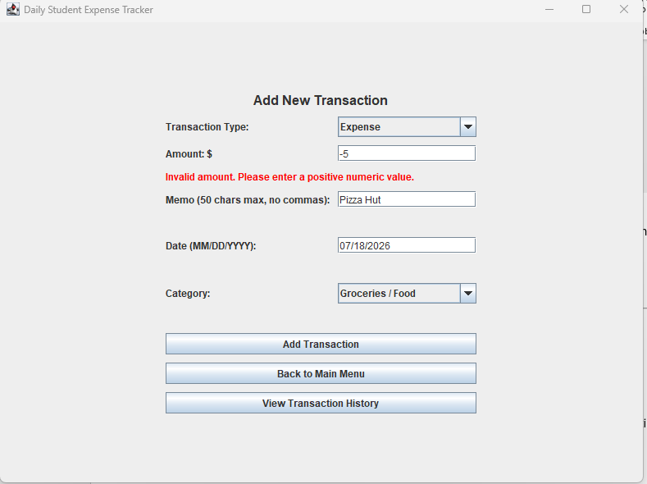  Fig 5. Several field errors at once. | 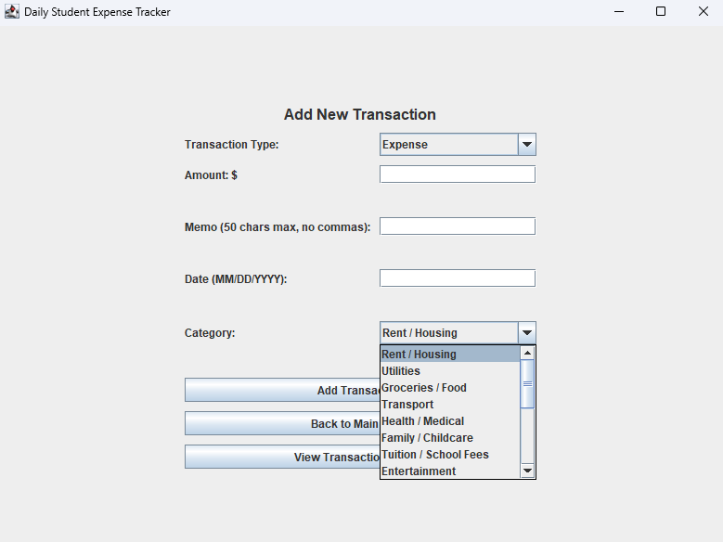  Fig 6. Expense categories dropdown.
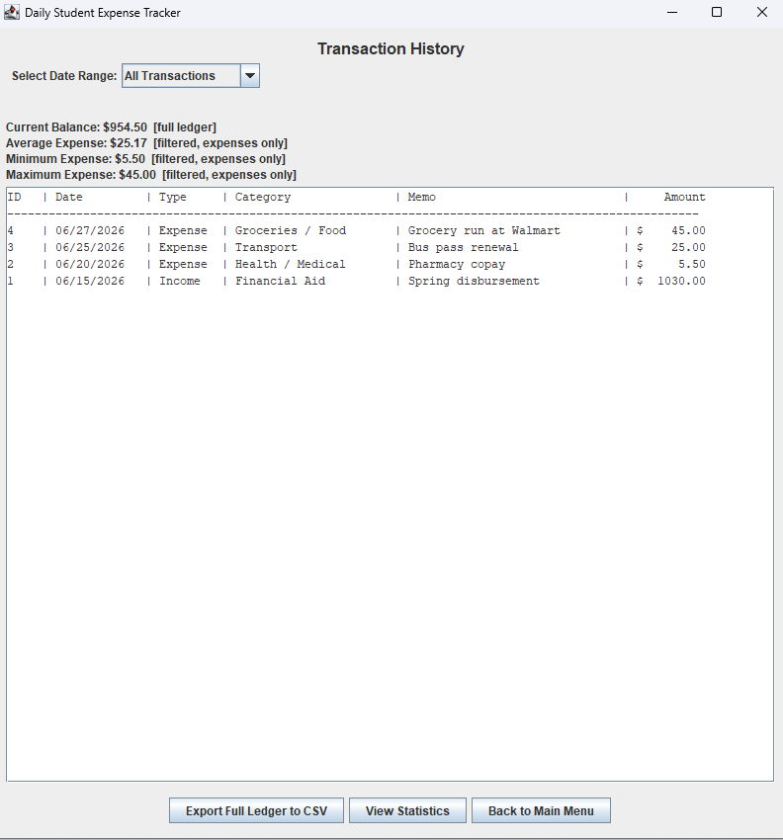  Fig 7. History, newest first, with stats. | 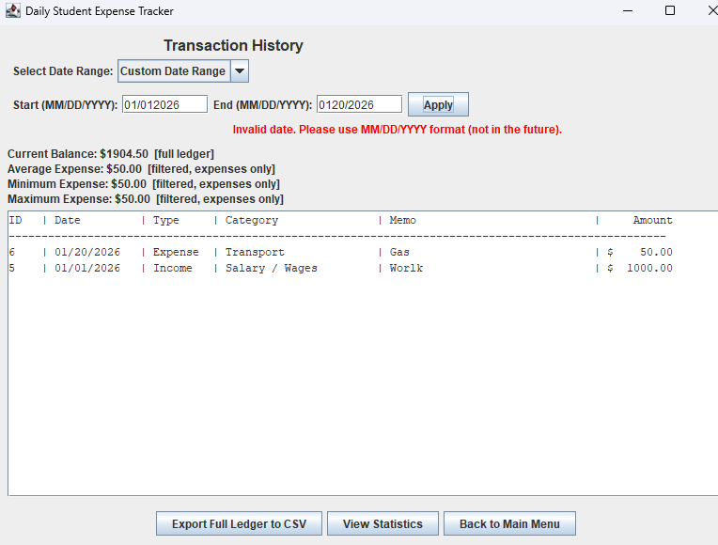  Fig 8. Custom range rejecting a bad date.
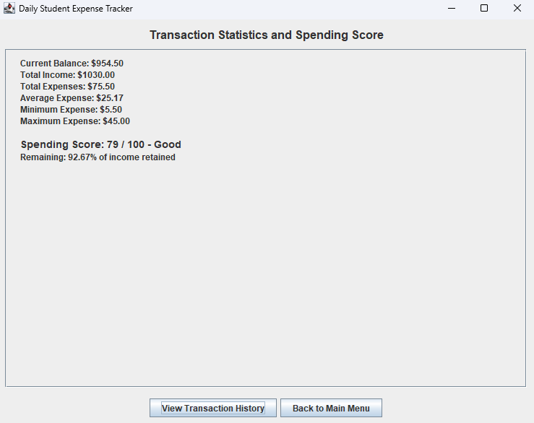  Fig 9. Statistics and Spending Score. | 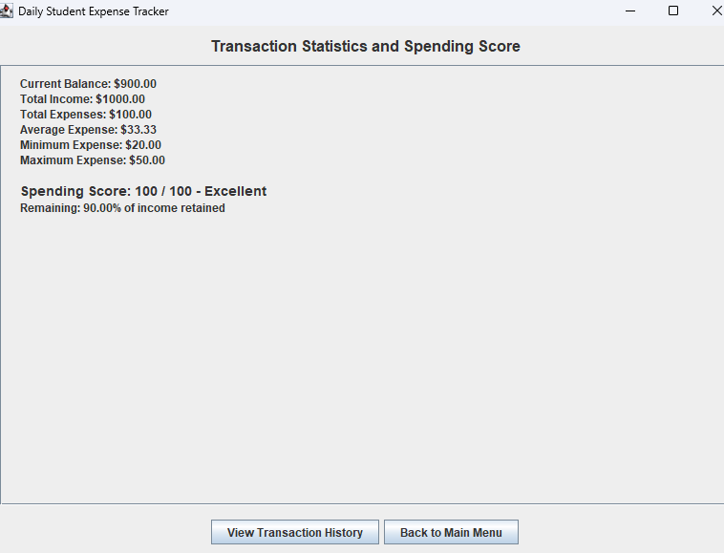  Fig 10. An Excellent score.
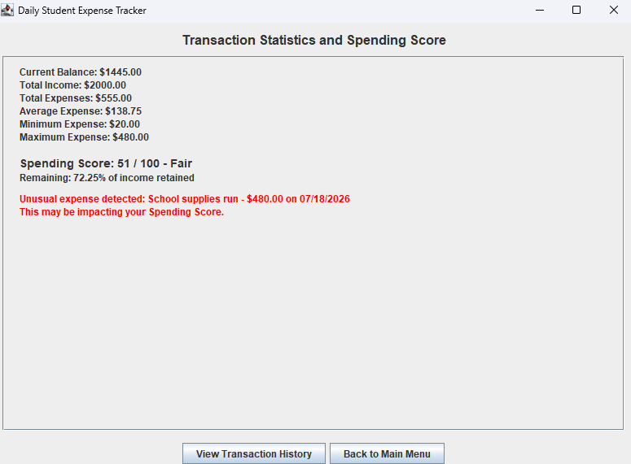  Fig 11. Unusually large expense flagged. | 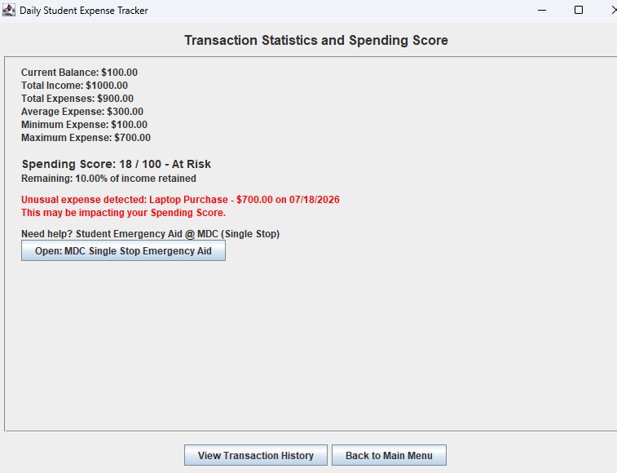  Fig 12. MDC resource links by score.
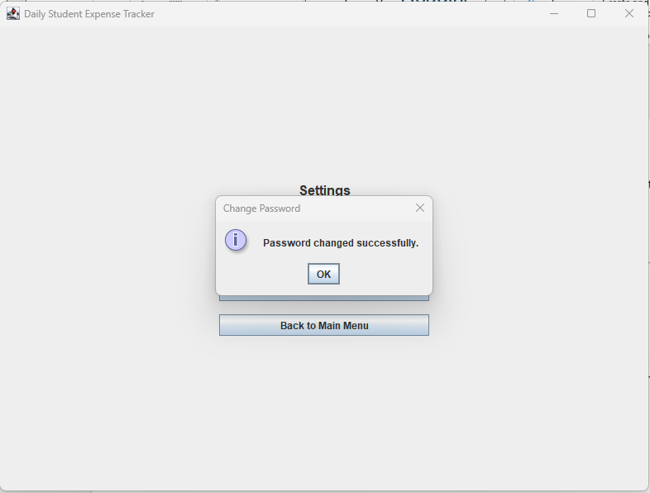  Fig 13. Password changed and saved. | 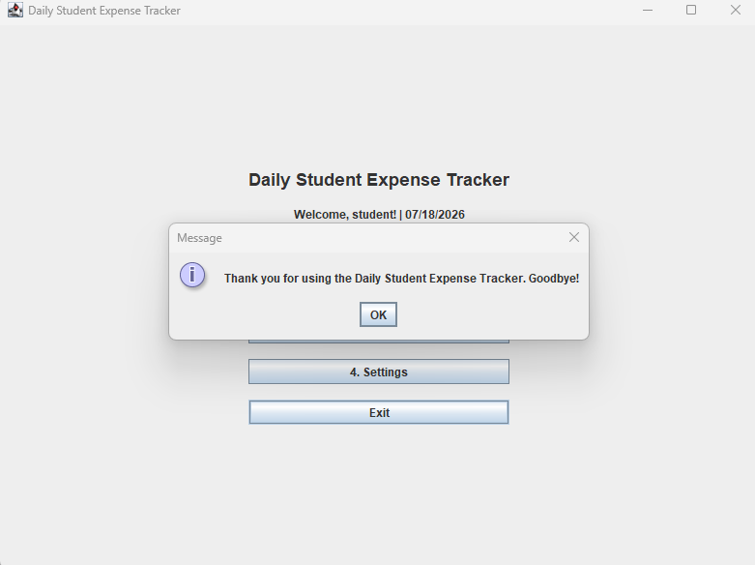  Fig 14. Save confirmation on exit.
Java Concepts Used
The program is split into five classes, each with one job. ExpenseTrackerApp builds the screens and handles navigation and validation. Transaction holds the data for one entry. ExpenseTracker owns the list of transactions and does the calculations. SpendingScore works out the score. FileManager reads and writes the CSV files.
Encapsulation is used throughout: fields are private and reached through getters. Inheritance shows up in ExpenseTrackerApp, which extends JFrame. The ledger is an ArrayList, and sorting uses Collections with a custom Comparator that converts the date strings into LocalDate objects so the comparison is correct rather than alphabetical.
The interface uses Swing components including JFrame, JPanel, JButton, JLabel, JTextField, JPasswordField, JComboBox, JCheckBox, JTextArea, JScrollPane, and JOptionPane. CardLayout switches between screens, and GridBagLayout, BorderLayout, and BoxLayout position the components. Buttons respond through ActionListener, written both as anonymous inner classes and as lambdas, and a WindowListener catches the window close event so the save still runs.
File reading and writing use BufferedReader and BufferedWriter. Dates use LocalDate and DateTimeFormatter. Every file and parsing operation is wrapped in try and catch, with specific catches for IOException, FileNotFoundException, NumberFormatException, and DateTimeParseException, plus a general catch on each one so that bad input produces a message instead of a crash.
Challenges and Lessons Learned
The interface caused the most trouble. Centering the MDC logo on the login screen took several tries, because GridBagLayout sizes its columns based on what every component asks for. One component with the wrong column number quietly shifted everything else, so the thing that looked broken was not the thing that was broken. That turned out to be a useful lesson: in a grid layout, check what all the components are claiming, not just the one that looks wrong.
Validation was more repetitive than expected. Each field needed its own check, its own error label, and its own branch in the save logic, and all of it had to stay consistent so the messages would read naturally. The MDC resource links also had to be redone when the URLs changed, which is a good argument for keeping values like that in one place instead of spread through the code.
The biggest change was to the Spending Score itself. The first version calculated the score from the remaining balance alone. After the class presentation, it was rebuilt as a weighted score: 60 percent balance health, 30 percent how closely spending follows 50/30/20 spending guidelines, and 10 percent unusual expense detection. That meant restructuring the SpendingScore class to receive the whole transaction list instead of two numbers, and it made the sample output from the design phase wrong. Rebuilding a core calculation after everything around it already worked was the clearest reason to settle weighting decisions during design rather than after.
Coming from Python and Swift, Java felt more structured and more demanding about stating things explicitly. Types, access levels, and exception handling all have to be written out rather than assumed. That felt heavy-handed at first, but it ended up helping: being forced to declare everything made the shape of the program visible when coming back to code written days earlier.
On the project side, the main challenge was balancing different expectations and availability across the team against the roles set out in the proposal. Work arrived at different times and in different states, which made it necessary to write decisions down as they were made instead of relying on everyone remembering the same conversation. A running decision log, a TODO comment on every choice that departed from the UML, and a written test plan all started as coordination tools and ended up making the work better.
With more time, four things would change: a longer development schedule, building the student support services in from the start instead of adding them late, adding a section that offers forward-looking financial tips rather than only scoring the past, and designing the Spending Score as a weighted calculation from day one.
Testing
Testing was done by running the application, not by reading the code. A five-part smoke test covered launch, transaction entry, history and statistics, export, and saving and reloading. The expected Spending Score was calculated by hand first and then checked against what the program displayed.
A separate test pass by a team member found four problems: the lockout timer resetting when the app restarted, the daily reminder setting not being saved, the password not being saved, and a precision limit on very large numbers. The two saving problems were fixed by adding a settings file, and a six-part follow-up check confirmed the fix worked and had not broken transaction storage. Two team members contributed thirty-four screenshots covering login, validation, history, statistics, filters, scoring, anomaly detection, and the resource links.
A written test plan of seventy-one cases covering startup, login, validation, history, statistics, scoring, settings, and edge conditions is included with this submission. The test runs described above are documented in full. The remaining cases in the plan are written out but were not all individually run within the project timeline.
Known Limitation
Java stores decimal numbers in a way that loses accuracy at very large values. If a transaction reaches into the hundreds of billions, the percentage of income remaining can display as unchanged even after a large expense is added. The app is meant for normal student budgeting amounts and formats all money to two decimal places. Fixing this properly would mean switching every calculation to BigDecimal, which was more than this project needed. It is recorded here rather than left unmentioned.

